**UNIT 4**

**1) List out the planning terminologies and components of planning:**

Planning is the process of setting objectives, determining strategies to achieve those objectives, and developing the plans to coordinate activities required to accomplish the objectives. Planning is a critical management function that helps organizations achieve their goals and objectives effectively and efficiently. There are several terminologies and components of planning that you should know. Let's discuss them in detail:

a) Goals and Objectives:

Goals are the desired results that an organization wants to achieve. Objectives are specific, measurable, and time-bound targets that help organizations achieve their goals. They define the desired outcome of a plan.

b) Strategies:

Strategies are the methods, techniques, and approaches that organizations use to achieve their objectives. Strategies help organizations make the best use of available resources and avoid potential obstacles.

c) Action Plans:

Action plans are detailed plans that specify what needs to be done, who will do it, when it will be done, and how it will be done. Action plans break down objectives into manageable tasks and provide a roadmap for achieving them.

d) Policies and Procedures:

Policies are general statements that guide decision-making and help employees understand what is expected of them. Procedures are detailed step-by-step instructions that employees follow to complete tasks. Policies and procedures provide a framework for decision-making and action.

e) Budgets:

Budgets are financial plans that allocate resources to different activities. They help organizations prioritize and manage their resources effectively.

f) Monitoring and Evaluation:

Monitoring and evaluation are essential components of planning. Monitoring involves tracking progress towards objectives and making necessary adjustments. Evaluation involves assessing the effectiveness of the plan and identifying areas for improvement.

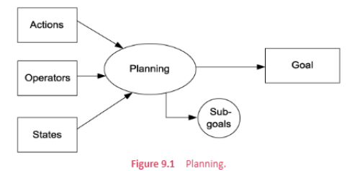

**2) Explain about Hierarchical planning method with examples:**

Hierarchical planning is a top-down approach to planning that involves breaking down objectives into smaller, more manageable tasks. Hierarchical planning is also known as "Command and Control" planning. This method is commonly used in large organizations where there are multiple levels of management.

The hierarchical planning process involves the following steps:

a) Setting Goals and Objectives:

The first step in hierarchical planning is to set goals and objectives. This is done at the highest level of management.

b) Developing Strategies:

Once goals and objectives are set, strategies are developed to achieve them. Strategies are developed by the top-level management.

c) Developing Action Plans:

Action plans are developed to break down strategies into smaller, more manageable tasks. Action plans are developed by middle-level management.

d) Implementing Action Plans:

Action plans are implemented by front-line employees. Front-line employees are responsible for carrying out the tasks outlined in the action plans.

e) Monitoring and Evaluation:

Progress towards objectives is monitored and evaluated by middle-level management. Adjustments are made as necessary to ensure that objectives are achieved.

Let's take an example to understand hierarchical planning better. Suppose a large manufacturing company wants to increase its market share by 10% in the next year. The hierarchical planning process for achieving this objective would be as follows:

a) Setting Goals and Objectives:

The top-level management of the manufacturing company would set the goal of increasing market share by 10% in the next year.

b) Developing Strategies:

The top-level management would develop strategies to achieve the goal. For example, they could decide to launch a new product, expand into new markets, or increase advertising and promotions.

c) Developing Action Plans:

Middle-level management would develop action plans to implement the strategies. For example, if the strategy is to launch a new product, action plans would be developed for product development, marketing, and sales.

d) Implementing Action Plans:

Front-line employees would implement the action plans. For example, product development teams would work on developing the new product, sales

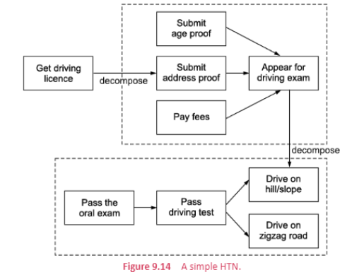  
(If u need content, it is not necessary)

**3) Explanation of STRIPS and its components for the given scenario: “Consider a flight journey in a luxurious flight from India to the US”**

STRIPS (Stanford Research Institute Problem Solver) is an early planning language used in artificial intelligence that provides a formal representation of the world and the actions that can be taken within that world. The language represents the world as a set of logical propositions and the actions as operators that can modify these propositions. STRIPS is a formalism that is used for describing the planning problem and finding the sequence of actions required to achieve a particular goal.

The components of STRIPS are:

i) States: States are the set of logical propositions that describe the current state of the world. In the given scenario, the initial state can be represented as follows:

* The flight is in India
* The passengers have boarded the flight
* The flight has not taken off yet
* The flight crew is present
* The passengers have their seatbelts fastened

ii) Goals: Goals are the set of logical propositions that describe the desired end state of the world. In the given scenario, the goal can be represented as follows:

* The flight has landed in the US
* The passengers have disembarked from the flight

iii) Operators: Operators are the actions that can be taken to modify the current state of the world. In the given scenario, the operators can be represented as follows:

* Board the passengers
* Fasten the seatbelts
* Take off
* Land the flight
* Disembark the passengers

iv) Preconditions: Preconditions are the set of logical propositions that must be true for an operator to be applicable. In the given scenario, the preconditions for the operators can be represented as follows:

* The passengers must be present to board them
* The seatbelts must be unfastened to fasten them
* The flight must be on the runway to take off
* The flight must be in the air to land
* The flight must have landed to disembark the passengers

v) Effects: Effects are the set of logical propositions that are true after an operator is applied. In the given scenario, the effects of the operators can be represented as follows:

* Board the passengers: The passengers are present in the flight
* Fasten the seatbelts: The seatbelts are fastened
* Take off: The flight is in the air
* Land the flight: The flight has landed
* Disembark the passengers: The passengers have disembarked from the flight

Therefore, STRIPS can be used to represent the given scenario as a planning problem by using the above components.

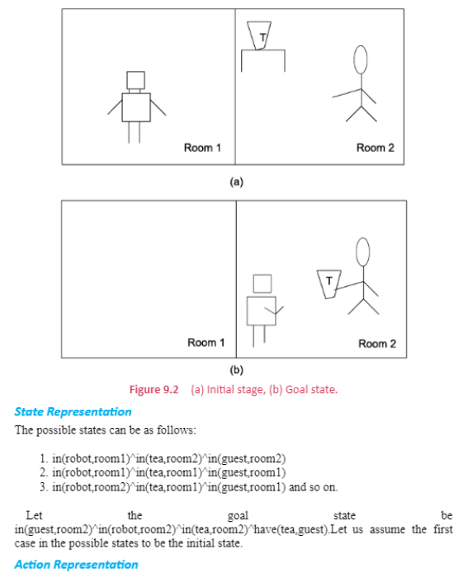

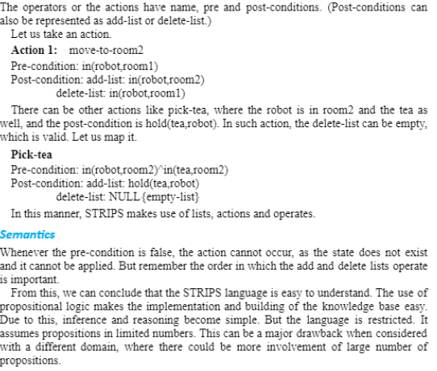

**4) What is Machine learning? Explain the types of machine learning.**

Machine Learning is a branch of Artificial Intelligence (AI) that deals with the development of algorithms and statistical models that enable computer systems to learn from and make predictions or decisions based on data, without being explicitly programmed to do so. In simple terms, Machine Learning is all about training machines to make decisions based on data, just like humans do.

**Types of Machine Learning:**

1. **Supervised Learning:** Supervised Learning is the most common type of Machine Learning, in which the system is trained on a labelled dataset that consists of inputs and their corresponding outputs. The goal of supervised learning is to learn a mapping function that can predict the output for new inputs based on the patterns learned from the training data. Supervised Learning can be further classified into two subtypes: Classification and Regression.

a) Classification: In classification, the goal is to predict the class or category of a given input. For example, a spam filter is a classification model that predicts whether an incoming email is spam or not. Other examples include image classification, sentiment analysis, and fraud detection.

b) Regression: Regression models are used to predict a continuous output value based on input variables. For example, predicting the stock price based on historical data, or predicting the sales of a product based on various factors such as price, advertising, and competition.

1. **Unsupervised Learning:** Unsupervised Learning is a type of Machine Learning in which the system is trained on an unlabelled dataset, with no specific output or target variable. The goal of unsupervised learning is to learn the underlying structure or patterns in the data. Unsupervised Learning can be further classified into two subtypes: Clustering and Association.

a) Clustering: Clustering is the process of grouping similar data points together based on their similarity. For example, grouping customers based on their purchasing behavior, or grouping images based on their visual similarity.

b) Association: Association is the process of discovering relationships between different variables in the data. For example, finding items that are frequently bought together, such as milk and bread.

1. **Semi-supervised Learning:** Semi-supervised Learning is a type of Machine Learning that combines both labelled and unlabelled data to train a model. The goal of semi-supervised learning is to improve the accuracy of the model by leveraging the unlabelled data, which is often much larger than the labelled data. Semi-supervised Learning is useful when obtaining labelled data is expensive or time-consuming.
2. **Reinforcement Learning:** Reinforcement Learning is a type of Machine Learning in which an agent learns to make decisions based on the rewards or penalties received from the environment. The goal of reinforcement learning is to learn an optimal policy that maximizes the long-term rewards. Reinforcement Learning is widely used in game AI, robotics, and autonomous systems.

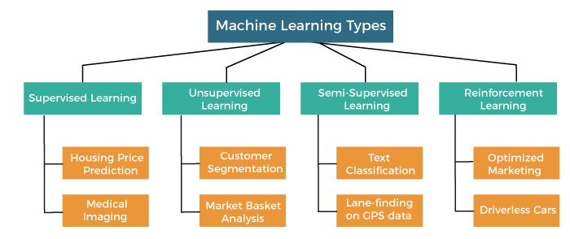

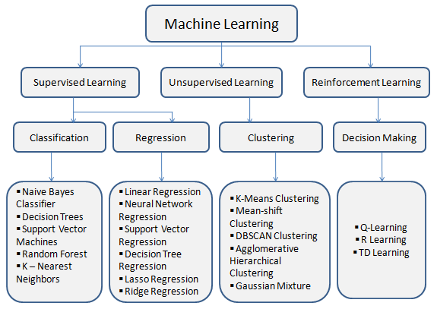

**UNIT 5**

**5) Expert System Framework:**

An expert system is an artificial intelligence program that utilizes knowledge and inference techniques to solve problems in a specialized field. It mimics the problem-solving capabilities of a human expert in a particular domain by utilizing a knowledge base and inference rules. In this answer, we will discuss the architecture, characteristic features, and roles of expert systems.

Architecture of Expert Systems:

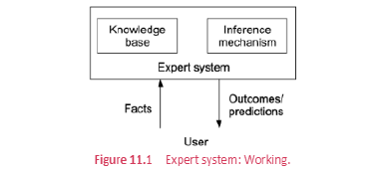

The architecture of an expert system consists of three main components: the knowledge base, the inference engine, and the user interface.

1. Knowledge Base: The knowledge base is the repository of knowledge that an expert system uses to solve problems. It contains both factual and heuristic knowledge about a specific domain. Factual knowledge refers to the information that can be presented as a set of rules or procedures, while heuristic knowledge is based on past experiences and judgment of experts. The knowledge base is created by knowledge engineers, who work with domain experts to encode their knowledge into the system.

2. Inference Engine: The inference engine is the reasoning mechanism of the expert system. It uses the knowledge in the knowledge base to draw conclusions and make decisions. The inference engine is responsible for processing user queries, matching them with the knowledge in the knowledge base, and providing solutions. The inference engine also utilizes different reasoning methods such as backward chaining, forward chaining, and rule-based reasoning to draw conclusions.

3. User Interface: The user interface is the means by which a user interacts with the expert system. It allows the user to input queries and receive output in a user-friendly manner. The user interface can be in the form of a command-line interface, a graphical user interface, or a natural language interface.

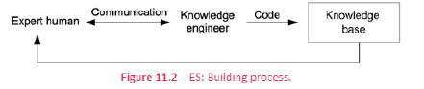

Characteristic Features of Expert Systems:

1. Domain Specificity: Expert systems are designed to solve problems in a specific domain. They contain specialized knowledge that is relevant to that domain and can be used to make decisions.

2. Decision-Making Capabilities: Expert systems are capable of making decisions based on the knowledge and rules encoded in their knowledge base. They can provide solutions to problems, recommend actions, or provide advice.

3. Explanation Capabilities: Expert systems can provide explanations for their decisions and recommendations. They can trace the reasoning process used to arrive at a conclusion and provide a rationale for the solution.

4. Learning Capabilities: Expert systems can be designed to learn from their experiences. They can improve their performance over time by adapting to changes in the domain and incorporating new knowledge.

Roles of Expert Systems:

1. Decision Support: Expert systems can assist decision-makers in making informed decisions by providing them with relevant information and recommendations.

2. Diagnosis: Expert systems can be used to diagnose problems in a particular domain. For example, medical expert systems can be used to diagnose illnesses.

3. Planning: Expert systems can be used to develop plans and strategies for a particular domain. For example, production planning systems can be used to optimize manufacturing processes.

4. Training: Expert systems can be used to train novices in a particular domain. They can provide explanations for their decisions, which can be used to educate users about the reasoning process.

Applications of Expert Systems:

1. Medical Diagnosis: Expert systems are widely used in the field of medicine for diagnosis and treatment. For example, MYCIN is an expert system that diagnoses bacterial infections and recommends antibiotics.

2. Financial Analysis: Expert systems can be used to analyze financial data and provide investment recommendations. For example, Decision Pro is an expert system that provides investment advice.

3. Manufacturing: Expert systems can be used to optimize manufacturing processes and improve production efficiency. For example, CRAFT is an expert system that provides guidance on the selection of manufacturing processes.

4. Customer Service: Expert systems can be used in customer service applications to provide assistance and resolve customer issues. For example, an airline might use an expert system to help customers rebook flights in case of cancellations or delays.

5. Agriculture: Expert systems can be used in agriculture to provide advice on crop management, pest control, and irrigation. For example, DSSAT is an expert system that provides guidance on crop management.

**6) Shells and Explanations:**

A shell is a software component that provides the basic framework for an expert system. It typically includes the inference engine, user interface, and explanation subsystem, but not the knowledge base. Shells are designed to be customized for a specific application by incorporating a knowledge base relevant to that domain.

There are two main types of shells:

1. Rule-Based Shells:

Rule-based shells utilize a set of rules to make decisions. These rules are typically written in an "if-then" format, where the antecedent is the condition, and the consequent is the action to be taken. Rule-based shells are useful in situations where there is a well-defined set of rules and where the domain is relatively simple.

2. Frame-Based Shells:

Frame-based shells utilize a knowledge representation technique called frames. Frames are used to represent objects, concepts, or situations and their attributes and relationships. Frame-based shells are useful in situations where the domain is complex and where there are many interrelated pieces of information.

Explanation subsystems are an essential component of expert systems, particularly in situations where the system's output may have significant consequences. The explanation subsystem provides a way for the user to understand how the system arrived at its decision. There are several types of explanation subsystems, including:

1. Rule Explanation:

Rule explanations provide a textual or graphical representation of the rules used by the system to arrive at its decision. Rule explanations are useful in situations where the rules are simple and easy to understand.

2. Case-Based Explanation:

Case-based explanations provide a textual or graphical representation of past cases where the system made similar decisions. Case-based explanations are useful in situations where the system's decision-making process is based on past experiences.

3. Model Explanation:

Model explanations provide a visualization of the system's decision-making process, allowing the user to see how the system arrived at its decision. Model explanations are useful in situations where the decision-making process is complex and difficult to understand.

4. Justification Explanation:

Justification explanations provide a justification for the system's decision, explaining why the system arrived at its decision based on the available information. Justification explanations are useful in situations where the decision may have significant consequences, and the user needs to understand why the system made its decision.

Applications of Shells and Explanations:

Shells and explanations are essential components of expert systems and have been successfully applied in various fields. For example, in the medical field, shells have been used to build expert systems that diagnose diseases based on a patient's symptoms and medical history. Explanation subsystems have been used to provide doctors with an explanation of how the system arrived at its diagnosis, allowing them to understand the reasoning behind the system's decision.

In the legal field, shells have been used to build expert systems that provide legal advice and assist in legal decision-making. Explanation subsystems have been used to provide judges and lawyers with an explanation of how the system arrived at its decision, allowing them to understand the reasoning behind the system's decision.

In the finance field, shells have been used to build expert systems that predict stock prices and make investment decisions. Explanation subsystems have been used to provide investors with an explanation of how the system arrived at its decision, allowing them to understand the reasoning behind the system's decision.

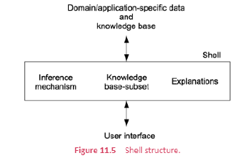

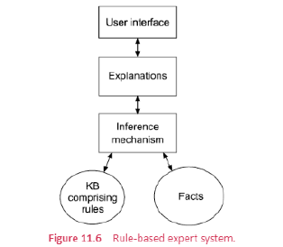

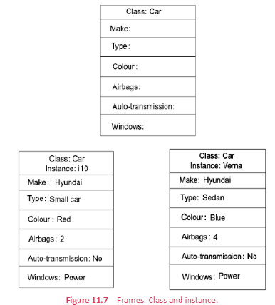

**7) Compare the convolutional neural networks, recurrent neural networks and summarize their pros and cons.**

Convolutional Neural Networks (CNNs) and Recurrent Neural Networks (RNNs) are two of the most popular neural network architectures used in Artificial Intelligence (AI) applications. While CNNs are mostly used for image and video analysis tasks, RNNs are preferred for time-series data analysis. Here is a detailed comparison between the two architectures, along with their advantages and disadvantages.

Convolutional Neural Networks:

Convolutional Neural Networks are a type of deep learning neural networks that are widely used for image and video analysis. They are designed to process data with a grid-like topology, such as images, and can learn to extract features automatically from input data. CNNs have several layers, including convolutional, pooling, and fully connected layers. The convolutional layer applies a set of filters to the input data, which extract features from the input. The pooling layer down samples the output from the convolutional layer, reducing the dimensionality of the data, and improving the computational efficiency. The fully connected layer then applies a set of weights to the pooled output, producing the final output.

Advantages of CNNs:

1. CNNs are very effective in image recognition and classification tasks.

2. They can learn to recognize patterns and features from input data automatically, reducing the need for manual feature engineering.

3. CNNs are highly scalable and can handle large datasets with high accuracy.

4. They are computationally efficient, thanks to the use of convolutional and pooling layers.

Disadvantages of CNNs:

1. CNNs require a lot of training data to achieve high accuracy.

2. They can be prone to overfitting if the dataset is not balanced or if there is not enough variety in the training data.

3. CNNs are not suitable for time-series data analysis, where RNNs are more appropriate.

Recurrent Neural Networks:

Recurrent Neural Networks are a type of deep learning neural networks that are used for time-series data analysis. Unlike CNNs, RNNs can handle sequential data, such as text, speech, and audio. RNNs have a feedback mechanism that allows information to persist from previous time steps, which enables them to capture the temporal dependencies in the data.

Advantages of RNNs:

1. RNNs can handle sequential data, such as text and speech, making them suitable for natural language processing tasks.

2. They can learn from past input, making them effective in predicting future outcomes.

3. RNNs are highly flexible and can be used for a wide range of tasks, including language translation, speech recognition, and music composition.

4. They can handle variable-length inputs and outputs, making them suitable for tasks with varying input and output sizes.

Disadvantages of RNNs:

1. RNNs can be computationally expensive, especially when dealing with long sequences.

2. They are prone to the vanishing gradient problem, where the gradients in the network become very small, making it difficult to learn from long-term dependencies.

3. RNNs require a lot of training data to achieve high accuracy.

Overall, CNNs and RNNs are two very different neural network architectures, each with its own set of strengths and weaknesses. While CNNs are preferred for image and video analysis, RNNs are better suited for time-series data analysis, such as speech and language processing.

Examples of CNN and RNN Applications:

1. CNN Applications: Image recognition, object detection, video analysis, autonomous driving, and medical image analysis.

2. RNN Applications: Language translation, speech recognition, music composition, sentiment analysis, and anomaly detection.

Certainly! Here are detailed answers to your questions:

**8) NLP and its Levels**

Natural Language Processing (NLP) is a subfield of Artificial Intelligence (AI) that focuses on the interaction between computers and humans using natural language. NLP deals with a range of tasks, including language generation, language understanding, sentiment analysis, speech recognition, and machine translation. NLP has several levels that reflect the complexity of the tasks and the sophistication of the techniques used to solve them. In this answer, we will discuss the different levels of NLP and the techniques used to solve tasks at each level.

Level 1: Tokenization and Part-of-Speech Tagging

The first level of NLP is tokenization, which involves breaking down text into individual words or phrases. Tokenization is often the first step in NLP tasks since it is essential to understanding the structure of the text. Once the text has been tokenized, the next step is Part-of-Speech (POS) tagging, which involves assigning each token a label based on its grammatical role in the sentence. POS tagging is necessary for understanding the meaning of the sentence and is used in several downstream tasks.

Techniques used for tokenization and POS tagging include regular expressions, rule-based methods, and machine learning-based methods. Regular expressions are used to match patterns in the text, while rule-based methods use predefined rules to assign labels to tokens. Machine learning-based methods use statistical models that have been trained on large datasets to predict the correct label for each token.

Level 2: Named Entity Recognition

Named Entity Recognition (NER) is the process of identifying and classifying named entities in text, such as people, organizations, and locations. NER is a crucial task in many applications, including information extraction and question answering.

Techniques used for NER include rule-based methods, dictionary-based methods, and machine learning-based methods. Rule-based methods use hand-crafted rules to identify named entities, while dictionary-based methods use lists of known named entities to match against the text. Machine learning-based methods use statistical models that have been trained on large datasets to predict the presence and type of named entities in the text.

Level 3: Parsing and Semantic Role Labeling

Parsing is the process of analyzing the syntactic structure of a sentence and representing it in a formal way. This involves identifying the relationships between the words in the sentence, such as subject-verb-object relationships. Semantic Role Labeling (SRL) is the process of identifying the semantic roles of each argument in a sentence, such as the agent or patient of a verb.

Techniques used for parsing and SRL include rule-based methods, statistical parsing, and dependency parsing. Rule-based methods use hand-crafted rules to analyze the syntactic structure of a sentence. Statistical parsing uses machine learning techniques to predict the most likely parse tree for a sentence, while dependency parsing identifies the relationships between the words in a sentence.

Level 4: Discourse Analysis and Pragmatics

Discourse analysis is the process of analyzing the relationships between sentences in a text and understanding how they contribute to the overall meaning of the text. Pragmatics is the study of how context contributes to meaning in language. Discourse analysis and pragmatics are necessary for understanding the meaning of longer texts and for performing tasks such as summarization and text generation.

Techniques used for discourse analysis and pragmatics include rule-based methods, statistical methods, and machine learning-based methods. Rule-based methods use predefined rules to analyze the relationships between sentences in a text. Statistical methods use machine learning techniques to predict the likelihood of different relationships between sentences. Machine learning-based methods use statistical models that have been trained on large datasets to predict the meaning of longer texts and to generate new text based on a given context.

Applications of NLP include:

1. Machine Translation: NLP is used in machine translation systems to automatically translate text from one language to another. Google Translate is a popular example of such a system.

2. Sentiment Analysis: NLP is used in sentiment analysis to automatically classify the sentiment of a piece of text as positive, negative, or neutral. This is useful for understanding customer feedback and social media sentiment.

3. Chatbots: NLP is used in chatbots to understand natural language inputs from users and generate appropriate responses. Chatbots are used in customer support, sales, and other applications.

4. Speech Recognition: NLP is used in speech recognition systems to transcribe spoken language into text. This is useful for applications such as dictation and voice-controlled devices.

5. Information Extraction: NLP is used in information extraction systems to automatically extract structured information from unstructured text. This is useful for applications such as resume screening and news article categorization.

**9) Information extraction and retrieval**

Sure, I can provide a detailed answer on information extraction and retrieval in the context of artificial intelligence.

Information extraction and retrieval (IER) are important techniques in the field of artificial intelligence that enable machines to identify and extract relevant information from large volumes of data. These techniques are used in a variety of applications, including web search engines, question-answering systems, and natural language processing.

Information extraction involves the process of automatically extracting structured information from unstructured or semi-structured data sources such as text documents, emails, or social media posts. This is accomplished by using natural language processing (NLP) techniques to identify and extract specific types of information such as names, dates, locations, and other entities of interest. Some of the most commonly used techniques for information extraction include named entity recognition, part-of-speech tagging, and dependency parsing.

Once the relevant information has been extracted, the next step is to store and retrieve it efficiently. Information retrieval is the process of searching for and retrieving relevant information from a large collection of data. This is typically done using search engines that allow users to enter queries and receive relevant results. In order to be effective, information retrieval systems must be able to match queries with relevant documents, even when the queries and documents are represented in different formats or languages.

One of the key challenges in information extraction and retrieval is dealing with the vast amount of unstructured data that is available. This requires the use of sophisticated algorithms and techniques that can identify patterns and structures in the data, as well as the ability to handle multiple data sources and languages. Some of the most commonly used techniques for information retrieval include probabilistic retrieval models, vector space models, and machine learning-based approaches.

One of the most common applications of information extraction and retrieval is in the field of web search engines. Search engines use sophisticated algorithms to analyze web pages and identify the most relevant content based on the user's query. This involves a combination of information extraction techniques to identify key entities and relationships in the text, as well as information retrieval techniques to match queries with relevant web pages.

Another application of information extraction and retrieval is in the field of question-answering systems. These systems are designed to answer natural language questions by extracting information from a variety of sources, including text documents, databases, and web pages. This requires the use of sophisticated algorithms that can identify relevant information and match it with the user's query.

In addition to these applications, information extraction and retrieval are also used in a variety of other fields, including healthcare, finance, and social media analysis. For example, in the healthcare industry, information extraction techniques can be used to extract patient data from electronic health records, while in finance, they can be used to extract financial data from corporate filings and news articles.

